Subject: EBDS Bill Package Bill Hold and Release
Original Date: May 2, 2023
Last Updated: May 2, 2023
Audience:
- Account Receivable – IMPACT Large Segment
- Case Installation – IMPACT
- Contract Drafting – FYI
- Enrollment – FYI
- eBusiness – FYI
- Learning and Performance – FYI (Use as needed)
- Shared Services Quality – FYI (Use as needed)
What you should know:
- Open Enrollment debrief – bill holds being released 'unknowingly'
- What we know today about bill hold and release
- Update to Rebill Database
- Update EBDS 'Comments' field using Subject 'BillHold'
Background/Details:
During the Open Enrollment debrief sessions a pain point was identified related to bill packages being released from bill hold 'unknowingly'.
Today the bill package in EBDS (Enterprise Billing Data System) may be placed on 'Bill Hold' for a variety of reasons.
For 'Bill Hold' release what we know:
- Today, there is no history to identify or track who placed the bill package on bill hold or released a bill hold.
- EBS is designed to only allow for one missed bill run.
  - There is a built in Automated Bill Hold release based on a pre-determine schedule typically 5 days prior to the next invoice production.
  - Example: BP on bill hold and missed the JAN invoice production
If the BP is still on bill hold – the BP will automatically release about 5 days prior to the FEB invoice bill run allowing JAN to produce prior to FEB.
- There was a break fix in September 2020 preventing bill holds from being released when the rates are changed on the Individual Rate screen for Ratemeta case.
- When there is an update in PERS, there is a logic in PERS-EBS Feed module NB7CD820 that checks whether all the CSA's in ACCNT is RATED or not under a particular PSUID. If it is rated, bill hold is removed automatically. Most of the time this is done in the background, might be overnight and BPC may be unaware it's happening and what was thought to be on bill hold is now released.
Since there is no Bill Hold history, we need your help to build a case to enhance our system.
A new reason code (Bill Hold Release Unknown) has been added to the Rebill QuickBase to allow us to track the volume and build a case to enhance our system.
Actions:
The following actions need to take place so we can gather as much data as possible to support the need for an enhancement.
Steps.
A. Place the Bill Package on Bill Hold
In EBDS/Bill Options Setup - add a comment under 'Comments'
A. Click COMMENTS
B. From the 'Subject' drop down select 'BillHold'
C. In the 'Comments' box include the bill package(s) and why the bill package(s) is on bill hold and your Aetna ID
D. Click 'Save Comments' and a popup will appear that comments were successfully saved.
E. The person who placed the Bill Hold (PSSC or BPC) should be checking daily to make sure the hold is still in place.
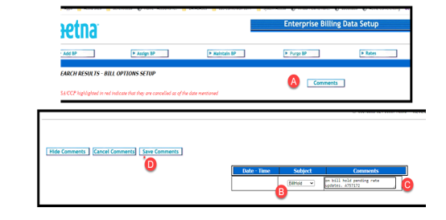
B. Rebill Database
If a bill hold was released unknown to you and you need to rebill
A. Follow the normal Rebill Policy
B. Select the new EBS Rebill Reason – 'Bill Hold Release Unknown'
C. In the EBS Comments include the date the bill hold had originally been placed and why as well as the EBS Ticket # if applicable
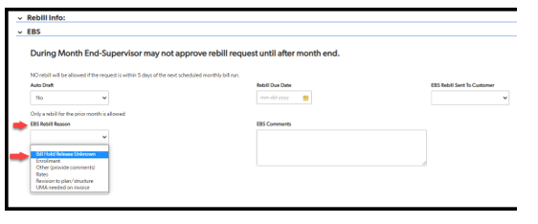
C. Submitting a ticket to EBS
A. When PSSCs or BPCs notice a bill hold is released and the reason is unknown, they should be submitting a ticket to the EBS Helpdesk, and they should also provide
details (screenshots if available); Noting in the Rebill database if a rebill has to take place due to the premature release of the bill hold

Questions:
Terri Kinney – KinneyT@aetna.com
Tammy Englund – EnglundT@Aetna.com
Sherry McRae - McraeS@aetna.com

